Task:

This exercise covers:

* Further shell scripting and the use of Regular Expressions
* An introduction to the sed stream editor

Work through the online tutorial demonstrated in class, the review the additional materials provided to you by the instructor in the Resources folder:

* “Special Characters, Regular Expressions and the sed editor.pdf”
* “grep and sed useful links.txt”, containing useful URLs

Print the Evaluation pages with the list of commands to execute and practice the contents. When you are ready for evaluation develop the script to perform the commands. Submit the script and specified files to the instructor for marking.

Evaluation:

This assignment is worth 15 marks. Please see the marking rubric below.

Assignment Notes:

The assignment must be completed and a copy of the Evaluation Sheet including a hardcopy of the script file created and the 3 versions of the corrected text files submitted to the instructor on or before the due date.

If your assignment is late please submit it to the Brightspace drop box to confirm submission. This will constitute the timestamp for evaluating any late penalty the assignment may incur.

**Marking Rubric**

**Name:**

|  |  |  |
| --- | --- | --- |
| **Marks** | **Score** | Item Description |
| **Set Up Work** | **N/A** | Before starting this assignment, fetch a copy of the file text_for_5.txt from the S: drive and put it in the Documents directory for your user on your Mint VM. Work with the commands in the shell before creating the final script for submission |
| **1** |  | There is a spelling mistake in text_for_5.txt, Linux is spelled Linix. Use the substitute command of sed to correct the spelling error and create an output file called 5corrected.txt. |
| **1** |  | Develop a regular expression that can find any room designation of a capital letter followed by a hyphen and then followed by exactly three digits. Use it to find the instructor’s office (C-147) in the file text_for_5.txt and use it in grep to locate the line. Do not use the literal string for the office number!  sed ‘s/\([A-Z]\)\([0-9]\)/\1-\2/g’ text_for_5.txt  (when saving it as well)  sed **-i** ‘s/\([A-Z]\)\([0-9]\)/\1-\2/g’ text_for_5.txt      Using grep to locate the line: |
|  |  | Output file: |
| **1** |  | Develop a regular expression to locate all lines in the file text_for_5.txt that begin with the word “and”. Use grep to list these lines. |
| **1** |  | Develop a regular expression to find the instructor’s last name in the file text_for_5.txt. Use grep to find it. Hint: there are apostrophes to account for in the required expression. Do not use the literal string for the name! |
| **1** |  | Develop a regular expression to find the instructor’s phone number in the file text_for_5.txt, use grep to find it. Do not use the literal string for the phone number, use a pattern to match any valid phone number! |
| **1** |  | Develop a regular expression to find all of the lines that end in “.” In the file text_for_5.txt, use grep to find them. |
| **1** |  | The word “sed” is misspelled as “seed” in the text. Use sed to correct it and output a file called 5_corrected_2.txt    Output: |
| **1** |  | Use the regular expression developed to find the instructor phone number and develop the sed command to add the area code 902- to the number. Append the file output to 5_corrected_2.txt (so it now contains answers to both questions).    Output: |
| **7** |  | Assemble a shell script to perform all of the commands in this assignment. Make a single call to the sed editor in the script. Please place all of the sed commands in a file of their own. Then make the sed substitutions with a single call to sed and redirect sed’s input to accept the commands rom the file you created. Output a file from sed called final_correct_5.txt  (**CHECK LAST PAGE FOR SCREENSHOTS)** |
| **Totals** |  | Submit: Your script, the file 5_corrected_2.txt, the file final_correct_5.txt and the file of sed commands |
| **15** |  |  |

0 - Assignment not submitted or work not original.

ALL COMMANDS:

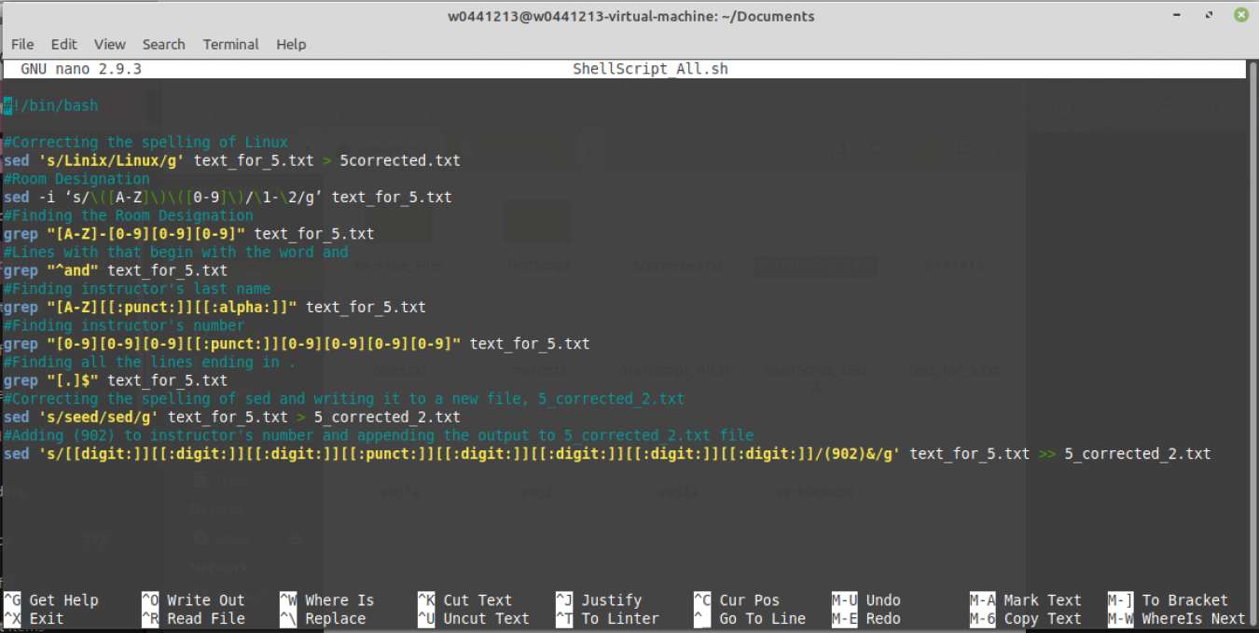

SED COMMANDS:

